**Connecting Smart Connector to ArcMC**

**Take a back-up of agent.properties from your connector home folder:{Connector home}/current/user/agent:**

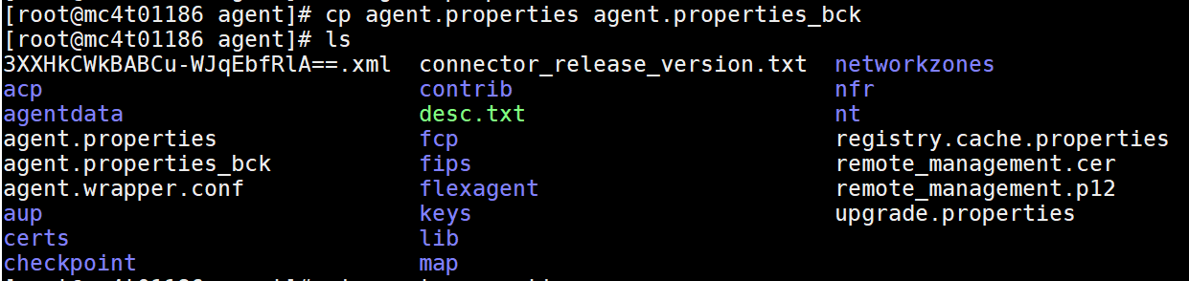

**Path of connector:**



**Add below details:**



**Restarting connector:**

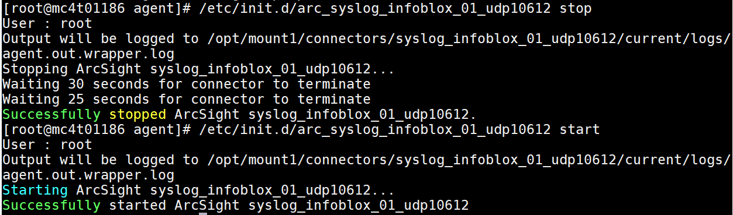

**Changes to be made in ArcMC :**

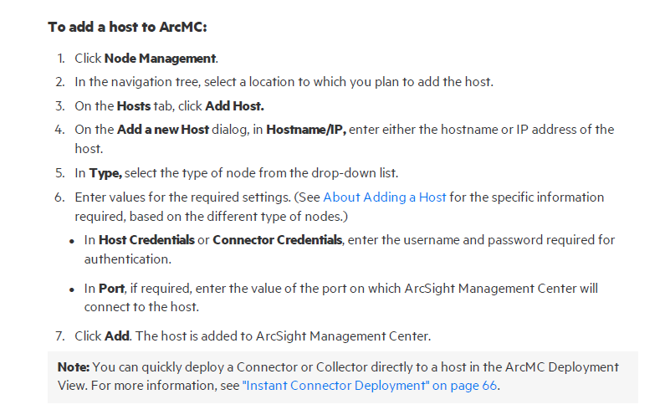

**Please refer ArcMC Administrator Guide Page 91.**